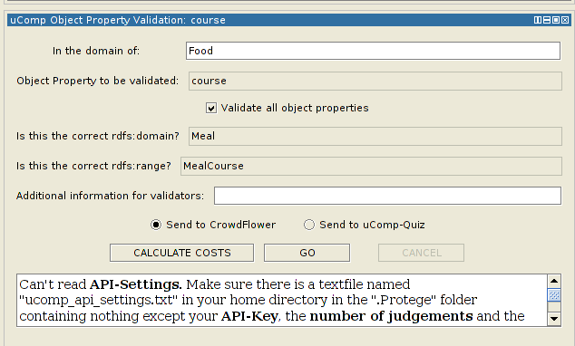
Another View ucomp PropertyDomainVerification → remove ObjectPropertyValidation
Property to be validated
Validate all data properties
Is this the correct domain


No range for data type properties

Another view : ucompPropertyRangeVerification

